*This mod must be used with the TerraFirmaCraft mod for Minecraft.*

## Introduction

This idea behind this mod is to allow the player to extract a small quantity of silver from the currently unused ore Galena. Several recipes and items have been added to the TFC mod. Careful thought has been given to the authenticity of each of the items and whether it was possible to do this at the TFC time periods.

The process and item construction have been simplified to allow the player to achieve the result without wasting too much time trying to gather resources and crafting the items.

Using the extraction process Galena can be used as a source of Silver, if Silver is hard to find in the world.

*Note: This process does not yield large quantities of Silver, as it was not designed to replace prospecting for Silver ore. It was implemented as an alternate until a larger source of Silver was found in the world.*

The use of vinegar as an early acid was decided upon as it was plentiful in the early stages. Using vinegar does not yield high results and as the player progresses through the game, Nitric acid can you used instead which yields better results than vinegar.

The ceramic battery was also decided upon as it has been around since 5000B.C.

## Process

The idea behind the extraction process is to construct a vessel that contains an acid solution to dissolve the Galena ore. Then using a cathode rod (carbon) and an anode rod (copper) connected to a power source (ceramic battery), the silver is attracted to the anode rod.

Using a knife, the silver accumulated on the anode rod, is then scraped off into Silver Flakes.

Those silver flakes can then be melted down using a small vessel and a fire pit or the crucible on the forge. When the silver flake is melted it becomes silver.

## Items

1. Anodising Vessel – this vessel is used to house the extraction process of silver from the Galena ore. It is a modified version of the large vessel introduced in the TFC mod.
2. Ceramic Battery – this vessel is used as a power source for the extraction process. It is a modified version of the small vessel introduced in the TFC mod.
3. Carbon Rod – the carbon rod is used as a cathode rod within the anodising vessel.
4. Copper Rod – the copper rod is used as an anode rod within the anodising vessel.
5. Copper Wire – the copper wire is used in the construction of the battery and the anodising vessel.

## Recipes

### Carbon Rod

The carbon rod is made using one piece of coal and a knife, in the crafting space. Any knife can be used.



### Copper Rod

The copper rod is made two ways, either using a ceramic mould or via an anvil plan.

To create the clay mould, use the follow knapping recipe. It then needs to be fired to make the ceramic rod mould.

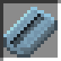

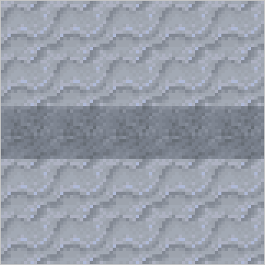

Using the ceramic mould, the player can heat copper ore using the small vessel and fill the mould.

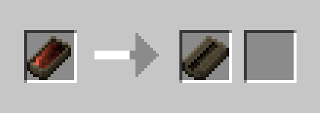

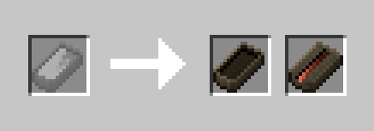

Then using the crafting space, the player can remove the copper rod from the ceramic mould. The ceramic mould is lost in the process.

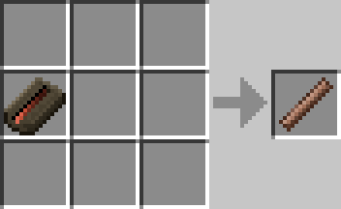

To create the copper rod using an anvil plan, place a workable ingot of copper in the anvil slot and click the plan button. Select the copper rod plan from the list.



The by using the anvil buttons, create the copper rod. You will get one copper rod per ingot.

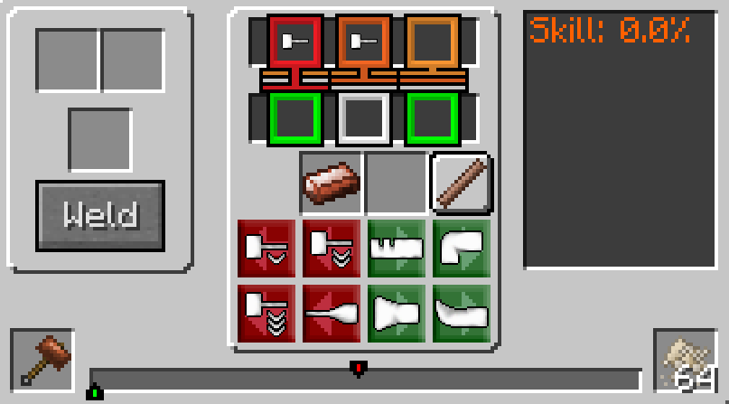

### Copper Wire

Copper wire can only be made using an anvil plan. Place a workable copper ingot into the anvil slot and click the plan button. Select the copper wire plan from the list.



Then by using the anvil buttons, create the copper wire. You will get 10 copper wires per ingot.

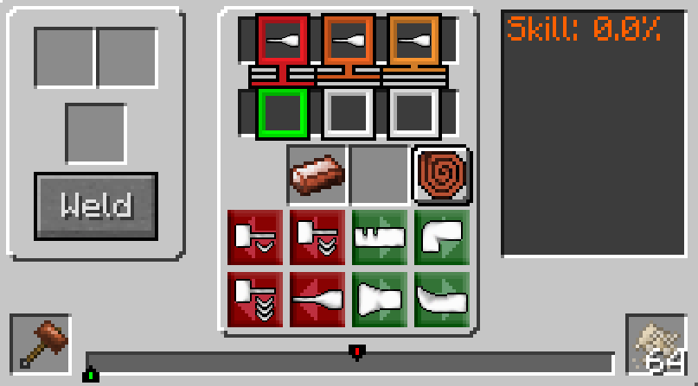

### Sulphuric Acid (Bottled)

Sulphuric acid is used in the construction of the battery and can be made in two ways. To make the acid the player requires - one bottled water and two sulphur powder.

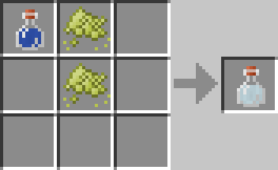

Or one bottled water and one gunpowder.

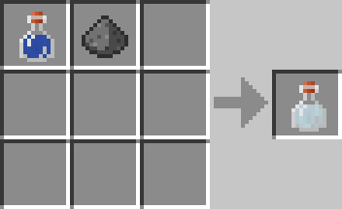

### Ceramic Battery

The ceramic battery is one of the four components used in the extraction process. To make the battery the player requires – one small ceramic vessel, one bottled sulphuric acid and two copper wires.

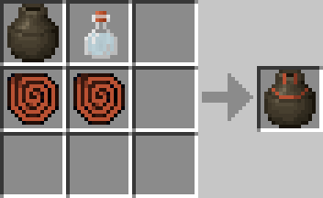

Recharging the battery can be done easily but adding more sulphuric acid to a ceramic battery.

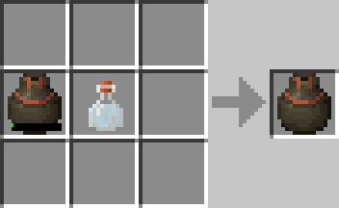

### Anodising Vessel

The anodising vessel is the container that houses the extraction process. To make the anodising vessel the player requires – one large ceramic vessel and two copper wires.

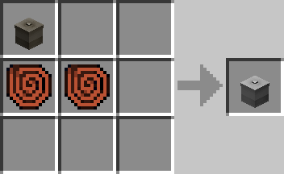

### Nitric Acid

Nitric acid is used as an alternate to vinegar in the extraction process. Using nitric acid over vinegar will yield better silver results, but also damage your cathode and anode rods quicker. To make the acid the player requires –

Filling the anodising vessel with fresh water, a minimum of 200mB is required. Then place 1 saltpetre powder per 200mB of freshwater into the slot. To make a full vessel of Nitric acid, 25 saltpetre powders are required.

*Note: Only the anodising vessel can be used to create the acid.*

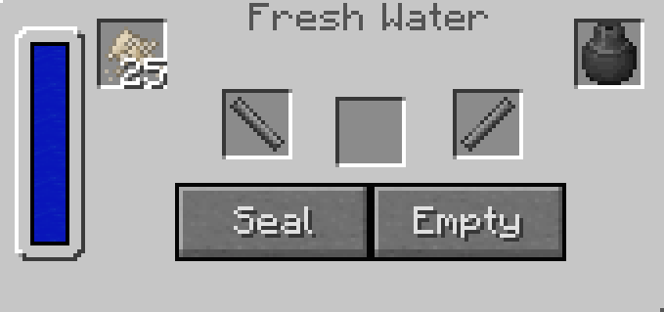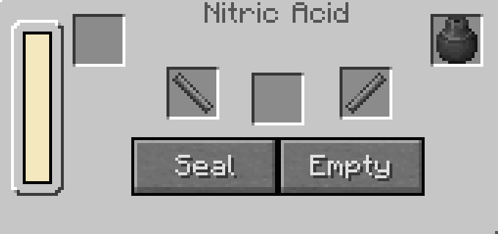

## Starting the Process

Before the process can be started the anodising vessel must be filled with an acid solution, either Vinegar or Nitric Acid. To fill the anodising vessel with vinegar, use a wooden bucket and transfer the liquid to the vessel, by right-clicking the vessel with the bucket of vinegar equipped. If the player wants to use Nitric acid, then use the recipe above, filling the anodising vessel with fresh water the same way they would with vinegar.

Note: The input slot cannot be used to fill the vessel with liquid.

The process is started by right-clicking the anodising vessel to open the GUI interface. Then the player drops the required items into the correct slots as shown below. The four required items are a Battery, Carbon rod, Copper rod and at least one piece of Galena.

*Note: The Galena can be any quality level. Higher quality levels yield more silver.*

Click the Seal button and if all the requirements are met, it should display ‘Processing’ at the bottom. If you see ‘Idle’ then the requirements were not met. Check that the battery has charge, and the copper rod is not fully damaged.

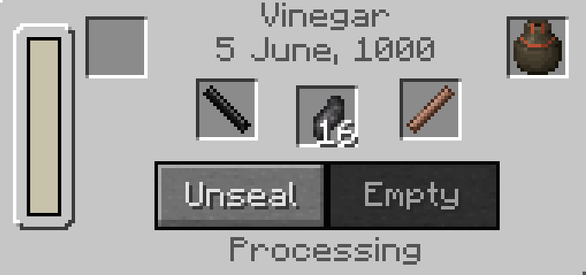

## Process Completed

At the end of the process, the copper rod will accumulate silver and the image will change.

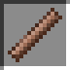

The player can see that the process is finished when all the Galena has dissolved and ‘Idle’ is shown. As each piece of Galena is dissolved and processed, the carbon rod and copper rod take damage. Also the battery charge is reduced.

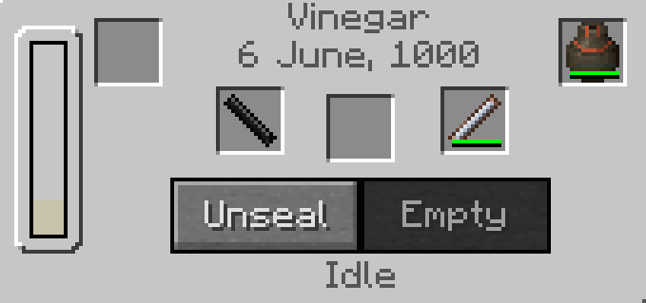

Click the Unseal button to unseal the vessel.

## Scraping the Silver

Once the process is finished and the vessel is unsealed, the copper rod (silver coated) can be removed from the vessel.



Put the copper rod in the crafting space with a knife to remove the silver flakes. In the crafting window, it shows your copper rod, but the Silver Flake will be added to the inventory. Any knife can be used.

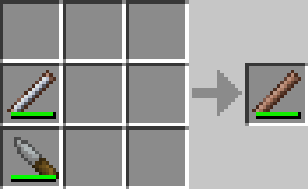

This is an image of the Silver Flake. Silver Flakes are 10 units and stack to 64. In the scraping process, if there is any excess silver flake left over a smaller stack is created.



The Silver Flake can now be melted down in a small vessel or using the crucible.